Install XAMPP program

Use this link to download XAMPP for Windows 64-bit:

<https://www.apachefriends.org/download.html>. Once you choose PHP 8.1.25, the file will start downloading right away.

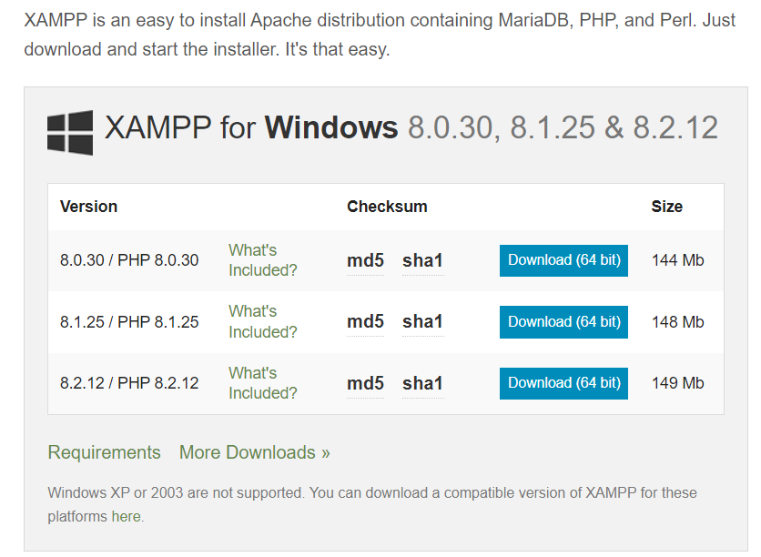

Setup the xampp by clicking on the download file.

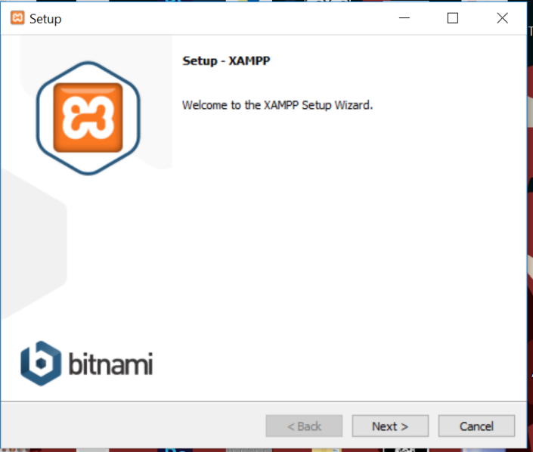

Follow the instructions to set up XAMPP.

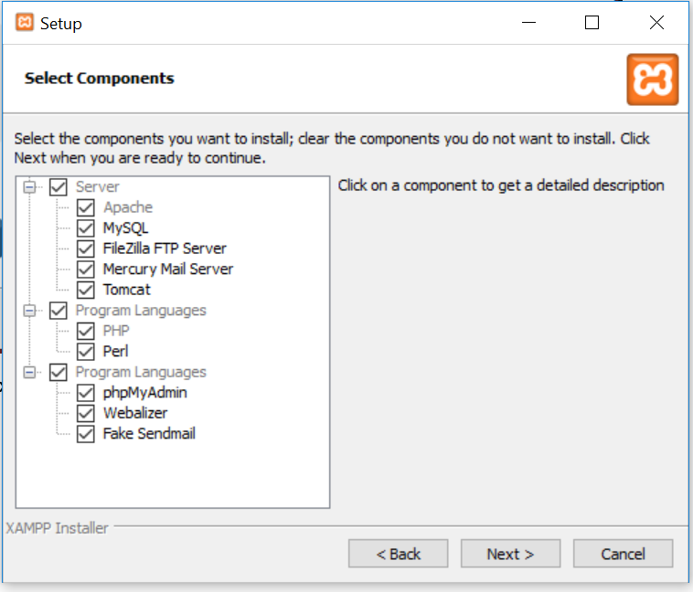

Keep the default checkboxes selected and click Next.

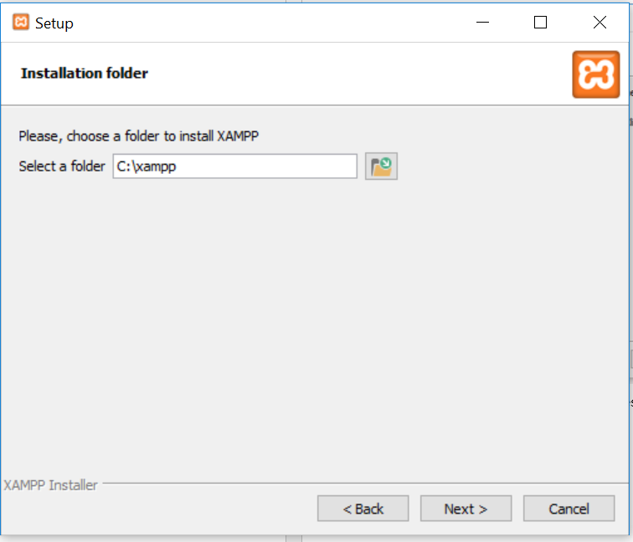

Install in C:\xampp and click Next.

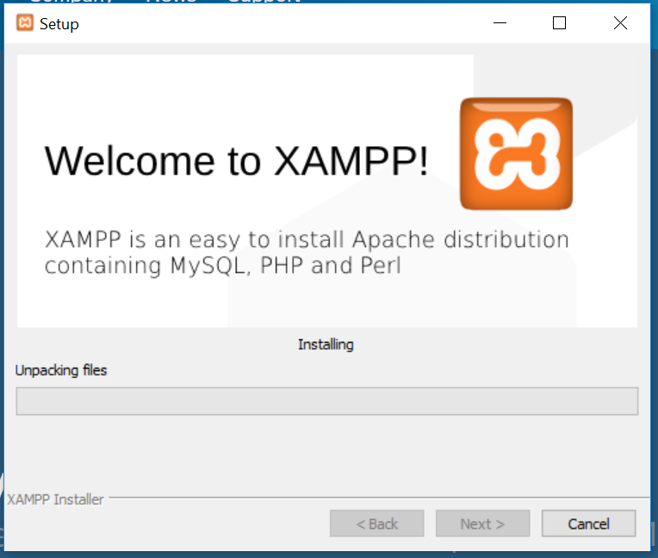

Press next and wait for the installation to complete

Once the installation is complete, open XAMPP and start the Apache server to test it.

